**Proposal Title:** Student enrolment forecast by State, Affiliation and Remoteness classification

**Team members:**

* Jasjeet Kaur
* Yao Ding
* Aravind Sama
* Hesh Kuruppuge

**Project description/outline:**

According to the Census date for the National school’s Statistical collection held every year, the latest data sets has been released August 2020 for primary and secondary education, in government and non-government schools, for all Australian states and territories. Even though the pandemic has affected data collection, the majority of schools were operated remotely and onsite time to time. According to the data set there were 4,006,974 total students enrolled in schools across Australia with slight increase compared to the 2019. Over the past 20-years, the government sector holds the most of the enrolment among other Affiliations.

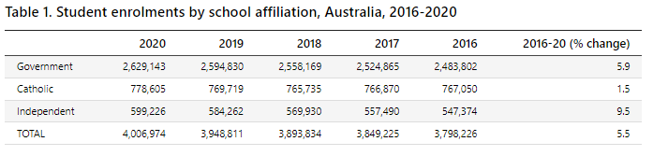

Throughout this project we will be referring ***three data*** sets and analysing them and answer (**Research questions to answer**)

* Number and percentage of all schools by school sector in each year (from 2009 to 2020)
* Number of Schools by **school type**, **Remoteness classification** and **state/territory**
  + - Which state is recording the highest enrolment percentage?
    - And how are enrolment numbers distributed among remoteness categories in each state?
* Percentage of schools by **school sector** and **school type**
* ***School sector****: Primary/Secondary/combined/special*
* ***School type****: Government/ Catholic/ Independent*
* **Remoteness classification**: Major city, Inner city, Outer city, Remote and Very remote
* Analyse historical/current enrolment details to see what matters for enrolment growth
* Aboriginal and Torres Strait Islander Student enrolments vs others
* The Capped Apparent Retention rates by Indigenous Status and state
* Throughout these years, has enrolment growth been decreased or increased based on Aboriginal and others?
* Throughout these years, has enrolment growth been decreased or increased based on state?
* Use all these analyses to forecast future enrolments

**Rough breakdown of tasks**

* Set the goal and the time lines
* Discuss with Uday and Shaheed to find we are in right track
* Start coding
* One team member can handle the documentation the same time as we do coding
* Do the visualisations - provide answers with images, graphs, tables
* Analysis and Conclusion
* Group presentation

**Datasets to be used**

Refer: <https://www.abs.gov.au/statistics/people/education/schools/2020>

**Three data sets will use among 20 data sets as below**

1. Table 46a Students (FTE) by ASGS remoteness Indicator,2020
2. Table 43a Full-Time Equivalent Student,2006-2020,
3. Table 63a Capped Apparent Retention Rates by Single Year (Grade), 2011-2020,